See this on Thursday, February 3
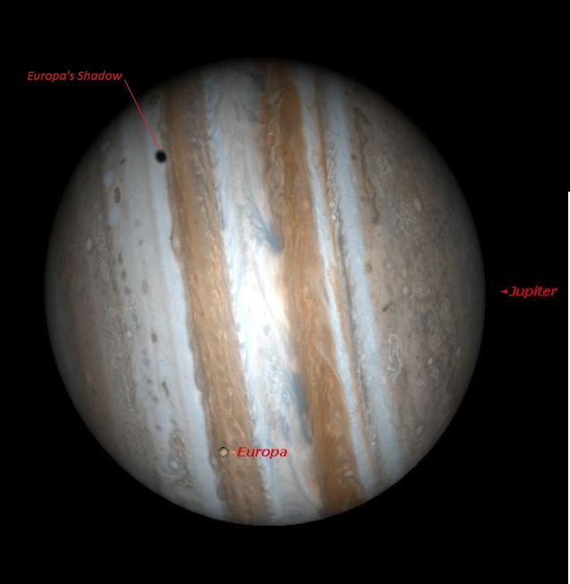
During our Annual Stargazing Night, Europa --one of four moons of Jupiter discovered by Galileo in 1610 – will pass in front of Jupiter. At around 7:30pm Europa’s shadow will follow it across the planet.
We will have telescopes pointed at Jupiter during these events in addition to other deep sky delights.

