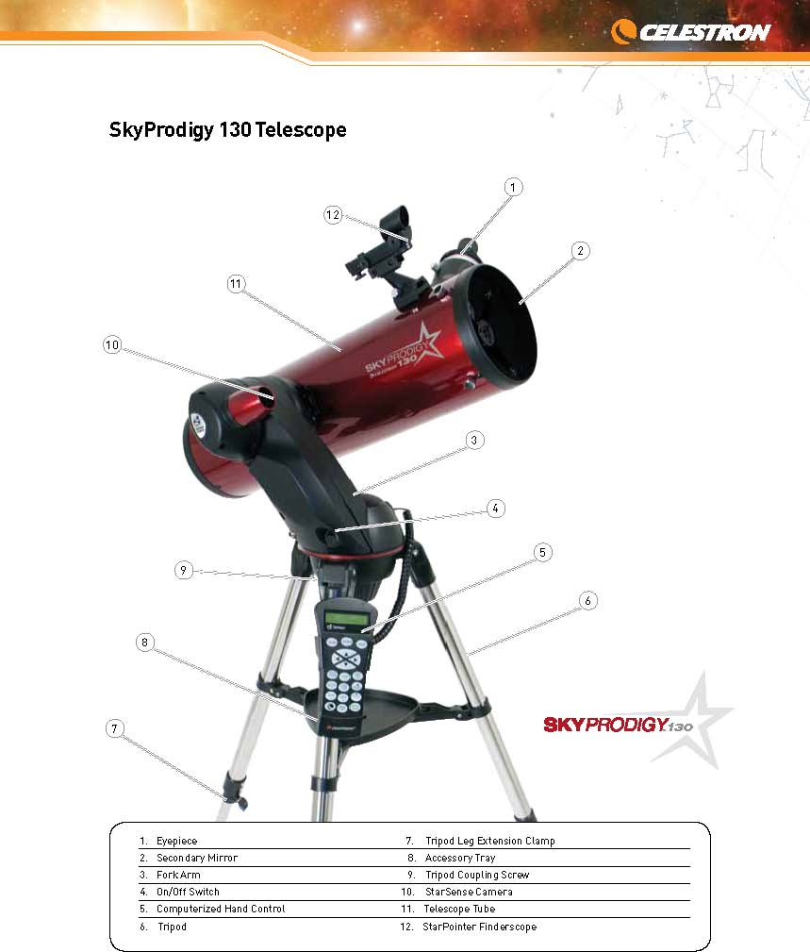fasdfasfdasdfafaf

This document is a “Quick Setup” field guide for the SkyProdigy 130, condensed from the Celestron SkyProdigy Computerized Telescope Instruction Manual. For clarity, references to the SkyProdigy 70 and SkyProdigy 90 have been removed. For complete instructions, please refer to the Celestron manual

All images and most narrative content is theirs. Highlighting is mine. Any errors are mine.

Contents
Assembly 3
Assemble the SkyProdigy 3
Set up the Tripod 3
Attach the Hand Control Holder 3
Attach the Fork arm to the Tripod 3
Attach the Telescope to the Fork Arm 4
Add the Accessories 4
Attach the StarPointer 4
Insert the Eyepiece 4
Connect the Computerized Hand Control 4
Powering the SkyProdigy 4
The StarPointer Finderscope 5
StarPointer Operation 5
Aligning the StarPointer 5

For Alignment Procedures please see the full Celestron Manual.

.

Assembly
SkyProdigy contains the following accessories:
- 25 mm and 9 mm Eyepieces – 1¼”
- StarPointer Finderscope and Mounting Bracket
- Deluxe Accessory Tray
- TheSkyX First Light Astronomy Software
- Computerized Hand Control

Assemble the SkyProdigy
The SkyProdigy comes in three major sections:
the optical tube, fork arm and tripod.

Set up the Tripod
First, install the accessory tray onto the tripod legs:
- Spread the legs apart until the center leg brace is fully extended.
- Locate the accessory tray, and place it on top of the tripod center support brace in between the tripod legs (see figure 2-1).
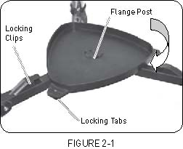
- Rotate the accessory tray so that the central hole in the tray slides over the flange post in the center of the support bracket.
- Rotate the tray so that the locking tabs slide under the locking clips on the support bracket. You will hear the tray snap into place.

It is a good idea to level the tripod and adjust the height of the tripod legs before attaching the fork arm and tube.
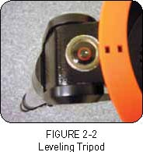
Note: the tripod does not need to be perfectly level.
To adjust the height of the tripod legs:
- Loosen the tripod leg locking bolt located on the side of each leg.
- Slide the inner portion of each leg down 6” to 8” inches.
- Adjust the tripod height until the bubble level on the tripod leg is centered (See figure 2-2).
- Tighten the tripod locking bolts to hold each leg in place.

Attach the Hand Control Holder
SkyProdigy comes with a snap-on hand control holder that conveniently attaches to any of the tripod legs. To attach the hand control holder simply position the holder with the square plastic tab facing up and push against the tripod leg until it snaps into place (See figure 2-3).
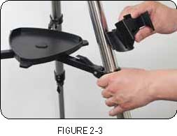

Attach the Fork arm to the Tripod
With the tripod properly assembled, the telescope tube and fork arm can easily be attached using the quick release coupling screw located underneath the tripod mounting platform:
- Place the fork arm base inside the tripod mounting platform.
- Thread the coupling screw into the hole at the bottom of the fork arm base and hand tighten (See figure 2-4). 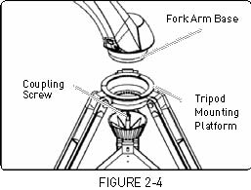

Attach the Telescope to the Fork Arm
Your telescope optical tube has a built-on dovetail mounting bar used to attach the tube to the fork arm. To attach the telescope tube:
- Loosen the tube clamp tightening knob.
- Slide the dovetail mounting bar of the telescope tube into the fork arm clamp until it touches the positioning stop. Make sure that the logo on the side of the tube is right side up when the tube is aligned with the fork arm.
- Tighten the tube clamp knob by hand to secure the tube to the fork arm.
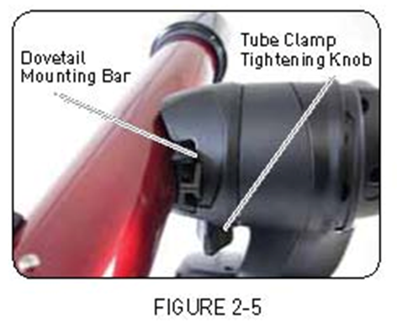
Your SkyProdigy is fully assembled and is ready to attach the accessories.

Add the Accessories

Attach the StarPointer
- Slide the StarPointer bracket into the dovetail mounting platform on top of the focuser assembly (see figure 2-14).
- Orient the StarPointer so that the sight tube is facing towards the front of the tube.
- Secure the StarPointer bracket by tightening the thumb screw on the mounting platform.
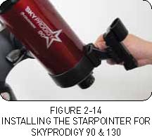

Insert the Eyepiece
The eyepiece is the optical element that magnifies the image focused by the telescope. The eyepiece fits directly into the focuser
- Loosen the thumb screw on the eyepiece adapter at the end of the focuser barrel and remove the protective dust cap from the focuser barrel.
- Select a wide angle low power eyepiece (the higher the focal length value, the wider the angle).
- Slide the chrome portion of the eyepiece into the eyepiece adapter.
- Tighten the thumbscrew to hold the eyepiece in place.
To remove the eyepiece, loosen the thumbscrew on the eyepiece barrel and slide the eyepiece out

Connect the Computerized Hand Control
SkyProdigy’s hand control has a phone jack type connector at the end of its cord.
- Place the hand control into its holder as described previously in the Assembly section of the manual.
- Plug the phone jack connector into the outlet at the base of the telescope’s fork arm.
- Push the connector into the outlet until it clicks into place.

Powering the SkyProdigy
SkyProdigy can be powered by 8 user supplied D-size alkaline batteries or an optional 12v AC adapter. To power SkyProdigy:
- Plug the battery pack or power pack connector into the 12v outlet on the base of the telescope.

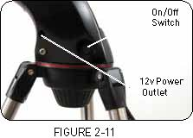
- Flip the power switch to the “On” position. The light on the
- power button and hand control display will come on.
In case of a loss of power, the optical tube can be moved by hand in altitude (up and down) only. However, when powered on, the telescope should always be controlled using the hand control.

Note: SkyProdigy will lose its star alignment if moved by hand when powered on.

.

The StarPointer Finderscope
The StarPointer is a zero magnification pointing tool that uses a coated glass window to superimpose the image of a small red dot onto the object you are viewing. The StarPointer is very useful for finding terrestrial objects in the daytime, and seeing where the telescope is pointing in the night sky.
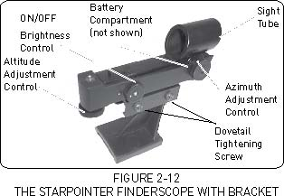

While keeping both eyes open when looking through the StarPointer, simply move your telescope until the red dot, seen through the StarPointer, merges with the object as seen with your unaided eye. The red dot is produced by light-emitting diode (LED); it is not a laser beam and will not damage the glass
window or your eye. The StarPointer comes equipped with a variable brightness control, two axes alignment control and mounting brackets.
Before the StarPointer is ready to be used, it must be attached to the telescope tube and properly aligned.

StarPointer Operation
The StarPointer is powered by a long life 3v lithium battery
(#CR2032) located underneath the front portion of the StarPointer.
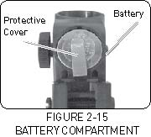
To turn on the StarPointer, rotate the variable brightness control (see figure 2-12) clockwise until you hear a “click”. To increase the brightness level of the red dot, continue rotating the control knob about 180º until it stops.
Make sure that you turn off the StarPointer when you are finished observing with the telescope.

Aligning the StarPointer
Like all finderscopes, the StarPointer must be properly aligned with the main telescope to for accurate pointing. This is a simple process using the azimuth and altitude control knobs located on the side and bottom of the StarPointer.
- Locate a distant object and center it in a low power eyepiece in the main telescope.
  - If aligning during the daytime, choose an object at least a quarter of a mile away.
  - If aligning at nighttime, select the Moon or a bright star that is easy to see.
- Use the four directional arrow buttons on the hand control to move the telescope side-to-side and up and down.
- With both eyes open, look through the glass window at the alignment star.
- If the StarPointer is perfectly aligned, you will see the red LED dot overlap the alignment star.
- If the StarPointer is not aligned, take notice of where the red dot is relative to the bright star.
- Without moving the main telescope, turn the StarPointer’s azimuth and altitude alignment controls until the red dot is directly over the alignment object (see figure 2-12).
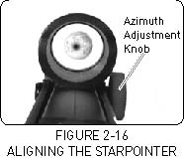

Note: If the LED dot is brighter than the alignment star, it may make it difficult to see the star. Turn the brightness control counterclockwise, until the red dot is the same brightness as the alignment star. This will make it easier to get an accurate alignment.
The StarPointer is now ready to use.

